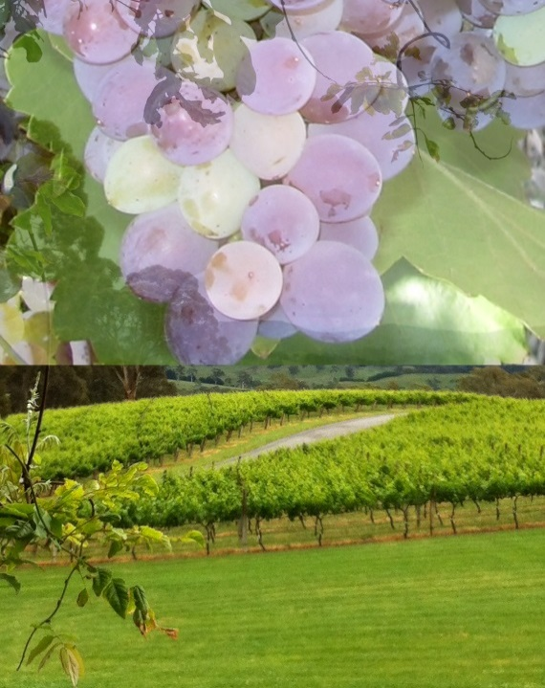

South Australian Wine Industry Plan

Introduction
The process to develop a South Australian Wine Industry Draft Strategic Plan commenced in May 2014 with the preparation of a vision and values statement. This received in principle support from the SAWIA and WGCSA Boards. Planning commenced and regional associations were surveyed seeking comment on the draft vison and values statement and suggestions for advancing cooperation. The results of the survey were presented at an industry roundtable in June 2015. That meeting strongly endorsed progressing the plan and a steering committee was established: Heather Webster, Chris Byrne and Peter Hackworth representing WGCSA and Ben Gibson replaced from February by Richard van Ruth, Jeremy Blanks, Tom Keelan, Brian Smedley and Jeremy Stevenson representing SAWIA.
The steering group agreed to prepare a draft value proposition, that was ‘coherent, capable of being communicated, recognises the hurdles and barriers and addresses them’. The group identified the following indicators of a successful SA Wine Industry:
- Awareness of, and capacity to respond to:
  - market changes (varieties, styles, packaging)
  - environment changes (climate change, events)
- Strong, in-demand brands
- High level infrastructure: water security, transport routes, power, telecommunications
- Early adopters of technology
- Clarity of purpose, roles, responsibilities
- Regulations that are fair, easily understood
- Strong representation to government, one voice
- Skilled managers and skilled staff
- Planning and investment confidence
- Continuous innovation – research, trial adoption
- Value Chain:
  - Profitability throughout the supply chain to enable investment in improvement
  - cohesive, values, connected
- Funds to deliver at industry level

The Steering Group further identified that a single plan would need to recognise and address
- Membership value
- Power imbalance between suppliers and processors
- Industry sustainability
- Transparency of end use
- Need to share risk fairly
- Capacity difference between regions
- Resourcing the plan to ensure the capacity to develop effective policies
Brian Smedley and Peter Hackworth were tasked to prepare a draft. That included consulting regional associations that had brought producers and processors together into a single structure.
The draft plan was presented to a joint meeting of SAWIA and WGCSA on Friday 3 June 2016. The meeting endorsed the three priorities (overleaf) and agreed to prepare a MOU for delivering the plan.

Delivering the Plan
The Steering Committee identified a number of priorities which are reflected in this plan:
- Water
- Changing climate
- Cost and reliability of utilities
- Transport
- Market and industry development
- Succession
- IR and WHS and
- Efficient production
Mindful of the limited resources of the two organisations and the need to deliver results from the plan the Steering Committee recommends that the plan initially focus on three areas that impact across the industry; managing seasonal cycles, cost of utilities and transport. This does not mean that the other issues will not be progressed, they are being – and will continue to be - addressed to varying degrees by WGCSA and SAWIA.

Vision
In 2020 the wine industry in South Australia is the most influential in Australia and is recognised as a global leader in wine production.
The industry in South Australia has an enviable reputation for:
- Strong brands
- Internationally recognised regions
- Quality at every price point
- Scale and diversity
- Old vines, iconic wines and heritage
- Connecting wine, food and tourism
- Biosecurity
We are efficient and profitable and, a critical economic pillar for South Australia.
We don’t stand still – we are constantly innovating and quick to adapt.
The associations are structured to deliver industry-wide strategy and we can prove the outcomes we achieve. We speak with one united voice.
This means the South Australian community has real pride in the industry.

Values
We value:
- Unity
- Diversity
- Sustainability
- Success

Strategic Priority One: Water

Key issues: Accessibility, Quality, Certainty, Cost. It is a complex area.
The industry is reliant on a combination of rainfall and supplementary water for irrigation from on-farm dams, the River Murray, ground water, recycled water and SA Water. Rainfall patterns are generally changing and are being impacted by higher evaporation rates. It is a complex policy area, including regional water allocation plans, the Murray Darling Basin Plan, SA Water delivery policies, etc. There are competing interests between industry and the environment and changing demands as the mix of types of users changes (e.g. growth of almonds, mining activity). The key issues are variable across and within-regions.

Past and current activities:
- Advocating for protection & conservation of water resources – engagement in enquiries and processes relating to competing interests and preservation (e.g. fracking)
- Engagement with government on water regulations and allocation (e.g. WAPs, MDB Plan)
- Educating the industry about the processes of water planning and the business impacts
- Monitoring developments and innovations in water technologies and informing industry about potential solutions

Goal: Sustainable use of water resources for all users.
Objectives | Strategies | Leadership | When | Resourcing
Ensure industry is effectively represented at policy level | Build expertise in water policy and prepare submissions to policy reviews (seasonal allocations, MDB Plan, WAP’s)  Work collaboratively with other industry associations and bodies | SAWIA |  | SAWIA/WGCSA
Promote efficient use of water in grape production and processing | Identify and promote best practice  Member education  Ensure irrigation is a research funding priority | WGCSA  WGCSA  WGCSA |  | SAWIA/WGCSA  SAWIA/WGCSA  SAWIA/WGCSA
Promote efficient use of water in wineries | Identify and promote best practice  Member education  Ensure research funding priority | SAWIA  SAWIA  SAWIA |  | SAWIA  SAWIA  SAWIA

Strategic Priority Two: Managing Seasonal Cycles

Key Issues: increased water requirement (drier, hotter), more heatwaves, compressed ripening, intake congestion, increased bushfire risk
Most regions in South Australia will be affected by a similar general trend that will impact the regional styles of wines and their composition (e.g. flavours and alcohol level). The industry will need to know and implement the adaptation options, including possible responses to a more Carbon-constrained economy (i.e. future carbon pricing). Compressed vintages and the resulting peak inflows are challenging the capacity of some wineries resulting in some fruit being harvested late and impacting on wine quality and prices paid for grapes.

Past and current activities:
- Sector agreement for education and voluntary emissions reduction targets
- Monitoring and educating industry about climate change projections (IPCC, BOM, CSIRO)
- Assisting industry to access funding to mitigate emissions through improved efficiency
- Understanding and engaging in climate policy and carbon markets
- Encouraging a systems management approach to improved environmental management and performance

Goal: Business sustainability in a changing climate
Objective One: Provide leadership on climate change
Strategies | Actions | Who | KPI | Reporting To | Reporting Date
- Monitor and interpret climate change information and projections | - Subscribe to climate projections and report sources (BoM, Climate Council, DEWNR, DAFF…) | SAWIA/WGCSA | - At least two sources subscribed | SAWIA-EnvC | Dec 2016
- Maintain a unified industry policy on climate change | - Establish Climate Change Working Group  - Engagement & development of policy  - Endorsement of policy  - Publish and promote policy  - Biennial policy review | SAWIA-EnvC  SAWIA/WGCSA | - Working group convened  - Policy developed and approved  - Policy on website; promoted twice per year  - Policy reissued biennially | SAWIA  SAWIA/WGCSA  SAWIA/WGCSA | July 2017  By July each year
- Educate industry about climate change | - Present seminar / industry briefing  - Provide industry with quick links from our website to relevant information  - Retain flexibility to respond to industry needs for information | WGCSA | - Be part of at least one event per year (e.g. AWIEC, Winegrape Summit)  - Information page with links on website | SAWIA/WGCSA | By July each year

- Engage with government and industry on managing seasonal cycles | - Participate in government adaptation planning processes  - Attend industry-based RD&E and planning events that are relevant (e.g. AWITC, AWRI, PIRSA-SARDI field days) | SAWIA/WGCSA | - Attend at least 2 workshops/yr (e.g. NRM, EPA, DEWNR, PIRSA)  - Attend at least 1 event per year | SAWIA/WGCSA | By July each year

Objective Two: Provide leadership on climate change responses
Strategies | Actions | Who | KPI | Reporting To | Reporting Date
Educate industry about  - the business benefits of improved environmental performance  - best practice in emissions reduction and climate change adaptation  - the roles and benefits of environmental management systems  - participation in carbon markets | - Prepare brief summary for industry on climate  - Continue annual Environment Excellence Awards program  - Expand to include a separate stream for Vineyard activities  - Prepare, publish and update ‘Leading Environmental Practice’ papers (LEP) on key topics:  - Resource efficiency  - Emissions reduction  - Adaptation  - EMS implementation  - Carbon accounting and pricing  - Energy Markets  - Vineyard posts life cycle | SAWIA/WGCSA  SAWIA  WGCSA/SAWIA  SAWIA/WGCSA | - At least 2 articles per year in Newsletters or other media  - Annual awards program to be delivered  - implement Vineyard category  - At least 1 LEP per year created/reviewed/updated and posted to website | SAWIA-EnvC, Boards  SAWIA  WGCSA/SAWIA  SAWIA | By July each year  AGM/Lunch each year  Sep 2018  By July each year

Objective Three: Increase industry participation in emissions reduction
Strategies | Actions | Who | KPI | Reporting To | Reporting Date
Seek opportunities to assist industry to:  - access funding for resource efficiency improvements  - to assist industry to participate in carbon markets | - Subscribe to relevant funding agencies (e.g. AusIndustry, Climate change, Environment)  - Attend briefings on programs and seek to collaborate to encourage participation in carbon markets | SAWIA/WGCSA | - At least two sources subscribed  - Attend at least 1 briefing per year or as required/available  - Alert growers to targets and encourage awareness of emission reduction | SAWIA-EnvC  SAWIA | Dec 2016  By July each year

Objective Four: Industry has the capacity to manage the impact of a changing climate
Strategies | Actions | Who | KPI | Reporting To | Reporting Date
Ensure climate change adaptation research and innovation is a funding emphasis | - Engage in AGWA R&D Planning process  - Prepare relevant submissions to government funding and research organisation proposals (e.g. AGWA 5-year Plans, AWRI Plans, SARDI Plans, Federal government) | SAWIA | - Respond to at least 1 consultation paper per year or as required | SAWIA/WGCSA boards | Update by July each year
Assist industry to adapt and respond to change by identifying negative impacts for targeted action | - Post-vintage annual review by Climate Change Working Group to identify climate-related issues and adaptation measures to inform policy responses  - Identify government programs to enhance capacity to adapt:  - Apply for funding for assistance projects  - collaborate with agencies to encourage participation | SAWIA/WGCSA Climate Change Working Group | - Climate Change Working Group convenes annual roundtable meeting and provides summary paper  - At least two sources subscribed  - At least 1 program initiated as per availability | SAWIA/WGCSA boards  SAWIA-EnvC; SAWIA/WGCSA boards | By July each year

Strategic Priority Three: Cost and Reliability of Utilities

Key Issues: Water – prices vary by source (i.e. river, dam, bore, reclaimed) and delivery mode, vineyards have highest input. Electricity – proportion of costs vary widely (i.e. 10-50% depending on business structure). Regulated monopoly utilities (SA Water, SA Power Networks) apply uniform pricing across South Australia.

Past and current activities:
- Advocacy – monitoring and engaging in regulatory pricing processes
- Educating industry about utility cost structures as well as energy (e.g. Winery Energy Saver Toolkit) and water use efficiency
- Assisting industry to access funding to improve efficiency (e.g. Lean)

Goal: Increase global competitiveness by minimising production input costs

Objective One: Ensure industry is effectively represented in policy processes
Strategies | Actions | Who | KPI | Reporting To | Reporting Date
Influence State Government and regulators in the processes of utility regulation and costing | - Participate in regulatory processes of energy and water markets at both State and National levels.  - Engage with relevant State departments on policy settings and their input to National policy (COAG)  - Identify key contacts (e.g. in DSD, DEWNR, ESCOSA)  - Collaborate with other industry organisations to access Government Ministers | SAWIA | - Prepare at least 2 submissions/yr to regulators on proposals and tariff structures (or as required)  - At least 2 meetings/yr with key government contacts  - At least 2 meetings/yr with industry organisations  - At least 1 contact request to relevant ministers per year | SAWIA-EnvC; SAWIA & WGCSA Boards | By July each year
Engage with industry to ensure that their views are articulated in regulatory processes | - Conduct issue based member surveys to collect data on cost/supply issues  - Engage members and seek input in preparation of submissions | WGCSA/SAWIA  WGCSA/SAWIA | - Issue included in annual grower/member survey  - At least 2 submissions/yr with member input | SAWIA-EnvC | By July each year

Objective Two: Increase the capacity of industry to minimise utility input costs
Strategies | Actions | Who | KPI | Reporting To | Reporting Date
Educate members through the identification and promotion of best practice in resource efficiency | - Provide best practice information on resource efficiency through seminars and other extension mechanisms  - Prepare, publish and update ‘Leading Environmental Practice’ papers (LEP) on relevant topics:  - Resource efficiency  - Emissions reduction  - Carbon accounting and pricing  - Energy Markets | SAWIA/WGCSA | - Present relevant information in at least one event per year (e.g. Summit, AWIEC, subject seminar)  - At least 1 LEP per year created/reviewed/updated and posted to website | SAWIA & WGCSA Boards  SAWIA | By July each year
Assist industry to access funding for resource efficiency improvements | - Engage and collaborate with Federal & State Government departments that provide funding opportunities for resource efficiency (e.g. DEE, GISA, EPA, DSD, DEWNR) | SAWIA | - At least 1 program that provides funding (directly or via SAWIA-WGCSA) operating at any time | SAWIA-EnvC | By July each year
Assist industry on implementing strategies for minimising costs | - Provide information and services to assist in understanding utility bills  - Establish partnerships with commercial suppliers and consultants to provide member benefits and enable improved utility usage efficiency | SAWIA/WGCSA | - Publish and promote relevant LEP papers in at least 4 Newsletter per year  - Seek to directly assist at least 15 members/yr in understanding their electricity bills and contracts  - Explore potential partnerships with at least 2 suppliers per year | SAWIA | By July each year
Ensure resource use efficiency research and innovation is a funding priority | - Engage in AGWA R&D Planning process  - Prepare relevant submissions to government funding and research organisation proposals (e.g. AGWA 5-year Plans, AWRI Plans, SARDI Plans, Federal government) | SAWIA | - Respond to at least 1 consultation paper per year or as required | SAWIA/WGCSA boards | Update by July each year

Objective Three Ensure industry understands the business impacts of utility market transformation
Strategies | Actions | Who | KPI | Reporting To | Reporting Date
Member education about energy market transformation | - Provide practical information on aspects of energy markets transformation that are relevant to the industry  - Prepare, publish and update ‘Leading Environmental Practice’ papers (LEP) on relevant topics:  - Energy Markets & Networks  - Electricity tariffs | SAWIA | - Present information in at least 1 event per year (e.g. Summit, AWIEC, subject seminar)  - At least 1 LEP per year created/reviewed/updated and posted to website | SAWIA & WGCSA Boards  SAWIA | By July each year
Monitor, interpret and report to industry, information on trends in utility markets | - Subscribe to relevant information sources for current market trends (e.g. water, electricity, gas)  - Provide relevant interpretative commentary to members on market trends for utilities | SAWIA/WGCSA | - At least 2 sources subscribed  - At least 2 articles per year in Newsletters or other media | SAWIA & WGCSA Boards | July 2017  By July each year

Strategic Priority Four: Transport

Key Issues: Regulations and their interpretation, transport during vintage
The wine industry is experiencing multiple challenges in terms of transport:
  - Identify, prioritise and lobby for infrastructure upgrades
  - Regulations that are not business-friendly and are not keeping up with technology (e.g. machinery sizes, in-board safety systems)
  - Compressed vintages and the rationalisation of processing facilities are impacting on grape delivery turn-around times and placing additional pressure on resources e.g. bins, trucks and drivers
  - Different interpretation by authorities of road transport regulations
  - Access to staff with appropriate skills and knowledge

Past and Current Activities
WGCSA has been involved with PPSA in the SA Government 90 Day Transport Project with a focus on last mile and B-Double access and is currently working with Transport SA to simplify the process for obtaining permits for moving over-sized machinery

Goal: Industry is able to efficiently transport grapes and wine
Objective One : Industry is effectively represented to government
Strategies | Actions | Agency | KPI | Reporting To | Reporting Date
Work with all sectors of the supply chain to identify issues and solutions for representation to government | Establish a stakeholder Transport and Supply Chain Committee (TASC) to identify key issues and key contact government regulators  Identify issues, discuss solutions and seek changes to regulations to remove unnecessary red and green tape | WGCSA  WGCSA | - TASC terms of reference agreed  - TASC meets twice a year  - At least 2 meetings with policy regulators  - Twice yearly updates in newsletters  - Continue active partnership with PPSA | SAWIA & WGCSA Boards | By June each year
Where appropriate partner with other organisations e.g. SARTA, PPSA, etc. to lobby governments | Exchange information, develop joint strategies, co-author submissions | WGCSA | - Meetings held as appropriate  - Joint submission to DPTI made | TWG | By June each year

Objective Two: Industry is informed on transport regulations
Strategies | Actions | Agency | KPI | Reporting To | Reporting Date
Member education and information resources | Develop and implement an awareness strategy | WGCSA | - At least two articles in newsletters  - Prepare and publish on website a Fact Sheet about Transport Regulations  - Review and update the Fact Sheet on Transport Regulations at least biennially | TWG | By July each year  June 2017  June 2019

Objective Three: Improve the efficiency of grape harvest and grape and wine transport
Strategies | Actions | Agency | KPI | Reporting To | Reporting Date
Identify industry practices and policies that reduce transport efficiency | TWG standing agenda item to identify and lobby for infrastructure upgrades  Undertake an annual post-vintage transport survey  Promote best practice in winery grape receival | WGCSA  WGCSA  WGCSA/SAWIA | - Proposal for changes to industry practices made on as need basis  - Survey undertaken and results reported to industry and implemented through the 90 day action plan as agreed with PPSA  - Prepare and publish on website a Fact Sheet about winery receival  - Review and update the Fact Sheet on winery receival at least biennially | SAWIA & WGCSA Boards  TWG | By June each year  By June each year  June 2017  June 2019
Assist industry to address harvest labour skill and supply shortages | Seek government funding to undertake a needs analysis/scoping study  Work with government to develop a response strategy | WGCSA  WGCSA | - Partner with appropriate organisations to offer appropriate training packages.  - Submission to government | TWG  SAWIA & WGCSA Boards | April  June

Strategic Priority Five: Market and Industry Development

Key Issues: Traditional activity and new trade related activity being undertaken, limited and short term funding supplied from government, Great Wine Capital membership, need for support in domestic and international promotions.
Increased linkages with federal Programs
Background
There is an ongoing need to increase consumer demand for South Australian premium wines in international and domestic markets by providing appropriate funding approval, project support and guidance to the State and regional association’s market and industry development programs in collaboration with the State government (PIRSA) using Project 250 funding. The industry has at times been unable to identify and respond to changing consumer demand, e.g. NZ Sauvignon Blanc, Prosecco, low alcohol wines

Past and current activities:
SAWIA established, promoted and activity under the brand Adelaide – the wine capital of Australia from 2013 together with the 365daysofwineandfood app. With the new Adelaide – South Australia, a great wine capital of the world brand a new emphasis and promotion needs to be developed with a collaborative effort.
SAWIA has administered market and industry development funding allocated to the SA wine industry since 2010 on behalf of the South Australian government (PIRSA). Funding has been secured over two four year funding cycles 2010-2014 and 2014-2018 coinciding with the term of government. There is no guarantee that further funding will be available beyond the current cycle.
SAWIA has attended State Government trade missions in support of South Australian wineries.
WGCSA conducts a periodic ‘Winegrape Growers Summit’ with the goal of providing early season market information to assist members in their business planning. WGCSA also collaborate and distributes wine crush data on an annual basis.

Goal: To provide market opportunities and platforms to promote and experience premium South Australian wine
Objectives | Strategies | Leadership | When | Resourcing
Encourage the market development programs of South Australian wine regions | Support the strategic market development plans of regions including South Australia in partnership with industry and government through project 250 funding. | SAWIA  SA wine regions | 2016, 2017, until June 2018 | Project 250
Leverage any opportunities for wine, food and tourism-based economic development in South Australia | Actively participate in establishing the brand “Adelaide – South Australia - a Great Wine Capital of the World” promoting Adelaide’s membership of the Great Wine Capitals Global Network (GWCGN) to South Australian wineries and consumers through events, activity and activation of domestic and international tourism awards.  Ensure the outcomes of membership and investment can be measured and reported.  Continue to support the 365daysofwineandfood app | PIRSA, SAWIA Brand South Australia, SA Tourism Commission  SAWIA | From July 1 2016  ongoing | PIRSA, SAWIA and wine regions, SATC and Brand South Australia  SAWIA
Provide wineries the opportunity to promote and market wines and interact with consumers | Ensure consumer facing activities associated with any initiatives demonstrate success for participants and are financially viable for participants and consumers.  Continue the National Wine Education & Training Centre courses held at the National Wine Centre with a focus on premium wines of South Australia from all wine regions. Continue with activity that promotes South Australian wine stories and messaging – Cellar Door experience, International Student Tastings. | SAWIA  SAWIA | Ongoing | Project 250
Securing and maintaining export markets for premium South Australian wine | Provide representation at all state government outbound trade missions and support any inbound trade related activities where a wine program is featured. | SAWIA | 2016, 2017 | SAWIA  Project 250
Industry has access to high level market intelligence | Work with Wine Australia and other intelligence bodies to ensure that market information is delivered to industry | SAWIA/WGCSA | Ongoing | Wine Australia + others

Strategic Priority Six: Succession

Key Issues: Aging workforce, attracting young people to a career in the industry and shrinking pool of people willing to take on industry roles
There is a shortage of skilled workers in peak periods. Some VET courses are no longer subsidised, raising the prospect of higher costs for educating workers. Some vineyard and winery families are encouraging the next generation to seek out careers in other industries. There is a bulge of older owners and managers approaching retirement age creating an opportunity for new entrants and advancement for those already in the industry but create challenges for a viable exit solution. There is anecdotal evidence of WHS implications of older workers with an increased risk of injuries.

Past and Current Activities
SAWIA has examined statistical evidence in relation to injury rates within the wine industry. WGCSA has undertaken research into why vineyard owners haven't exited the industry.

Goal: Industry succession is underpinned by training, skilled employees and leadership renewal is occurring at regional state and federal level.
Objectives | Strategies | Leadership | When | Resourcing
Access to trained and skilled employees | Continue the industry skills working group (SAWIA Employee Relations Sub-committee) to develop an industry education and training strategy to meet existing and anticipated skill shortages  Effective representation of industry skill and training needs to government and education and training providers. | SAWIA/WGCSA  SAWIA /WGCSA | 2017  Ongoing | SAWIA/WGCSA  SAWIA /WGCSA
The wine industry is a career of choice for young people | Continue to support www.careersinwine.com.au  Work with education/training institutions to market wine industry careers  Develop an industry traineeship program | SAWIA/WGCSA  SAWIA/WGCSA  SAWIA/WGCSA |  | SAWIA/WGCSA/TAFESA/ University of Adelaide  SAWIA/WGCSA
Succession planning | Work with relevant organisations to deliver succession planning information | WGCSA |  | WGCSA
Promote industry leadership participation | Establish limited-life, working groups that bring emerging leaders together to address industry issues  Use multiple messaging platforms to encourage broader engagement about industry issues.  Widely promote industry successes to establish within industry members a sense of value in being engaged in industry issues. | SAWIA/WGCSA  SAWIA/WGCSA  SAWIA/WGCSA |  | SAWIA/WGCSA  SAWIA/WGCSA  SAWIA/WGCSA

Strategic Priority Seven: Industrial Relations & Work Health and Safety

Key Issues: Simplify Award provisions to meet business needs, access to skilled labour in regions and aging workforce.
Industry employers are impacted by high labour costs under Awards during peak periods (e.g. vintage and pruning) and in cellar doors operating on Sundays and public holidays.
Workplace safety is a regulatory requirement that continues to provide challenges to employers who endeavour to become compliant cost effectively.
Providing information and education for members that assist them to comply in practical ways.

Past and current activities:
SAWIA:
- Expansion of Award definition of “vintage” to reflect Australian wine region conditions.
- Application submitted for reduction of penalty rates on Sundays, expansion of ‘ordinary hours’ during vintage for vineyard, laboratory and cellar.
- Monitoring and defending Award changes sought by Unions that seek to increase employment costs and impose greater regulation (e.g. apply a minimum number of hours a part time employee can be engaged for each week).
- Active engagement with Government regulatory bodies (SafeWork SA, ReturnToWork SA and Country Fire Services) about reforms/policy impacts on business, driving practical compliance and safer workplaces.
- Advocating on industry’s behalf with regard to legislative reviews and reforms in IR, WHS, workers compensation and training and skills.
- Submissions and appearances regarding reforms to Australia’s industrial regulation and the use of labour hire in the wine industry.
- Delivery of information sessions on the use of labour hire in the wine industry with a focus on managing the risks associated with WHS, migration and employment requirements (e.g. host employer).
- Advocacy relating to labour hire as a legitimate form of employment and necessary.
- Appointment to the South Australian Minister’s Industrial Consultative Committee.
- Appointment to the Food, Beverage and Pharmaceutical Industry Reference Committee dealing with Vocational Education & Training.
- Regularly review WHS Guidelines to ensure it is current with wine industry issues and trends, ensure this resource remains relevant and useable.

WGCSA has taken a limited role in IR & WHS matters:
- A ‘Guide to Employing Vineyard Workers has been produced and updated and related templates prepared
- Between 2011 and 2017 it has subsidised member access to an advisory service in partnership with Mediation and Employment Relations Services but is now in a partnership with SAWIA.

Goal: Maximise productivity in operations, build harmony and understanding of compliance obligations
Objectives | Strategies | Leadership | When | Resourcing
Ensure industry is effectively represented in relation to industrial reforms | Continue with 4 Yearly Award Review application  Monitor, comment and defend Award and legislative changes that impact wine industry employers | SAWIA  SAWIA | 2016/17  Ongoing | SAWIA  SAWIA
Adequately trained workforce | Identify skilled labour requirements for regions.  Managing workplaces as workforce age | SAWIA  SAWIA | Ongoing  Ongoing | SAWIA  SAWIA
Improve employer understanding & knowledge of employment/IR/WHS laws | Identify, develop and run workshops / seminars to ensure ongoing knowledge about existing laws and any new compliance obligations.  Maintain the ability to provide an advisory service by phone, email or face to face. | SAWIA  SAWIA | Ongoing  Ongoing | SAWIA  SAWIA
Promote adoption of good practice IR/Human Resources /WHS | Circulate practical information and facilitate useful sessions for employers | SAWIA | Ongoing | SAWIA
Build, maintain and foster productive relationships with key stakeholders in relations to IR, HR and WHS | Industry employers/owners  Government agencies  Wine industry organisations – national, state, regions  Other employer and employee associations  Private sector providers that benefit (directly or indirectly) to industry | SAWIA | Ongoing | SAWIA

Strategic Priority Eight: Efficient Policy, Legislation and Regulation

Key Issues: Costs of doing business, unnecessary red tape, complex and difficult to understand legislation and regulations
Government and industry policies and practices have developed over time with a negative impact on efficiency and productivity.
State wine industry associations in general are reactive rather than providing clear agendas and solutions to managing issues impacting on industry.
Developing clear and meaningful industry policy in key areas would assist in appropriate and consistent messaging to regulators and enforcers.

Past and current activities:
Constructive and good relationships built with relevant Government Minister’s and departments that have influence over the wine industry.
Provided written submissions (to legislative reviews) and appearances (to Parliamentary enquiries) to strongly represent the interests of the wine industry.

Goal: Actively commit to providing input and response to government in matters impacting the South Australian wine industry
Objectives | Strategies | Leadership | When | Resourcing
Ensure the industry has developed policy in key areas to influence government. | Consult widely to understand the issues that are having or the potential to have an impact on industry efficiency and productivity  Develop appropriate policies in response  Review policy for relevance at regular intervals  Ensure industry policies on key issues are prepared prior to the election of the next State Government  Identify key legislative areas requiring input through submissions  Undertake representation as required – parliamentary committees, reviewers appointed by government | SAWIA/WGCSA | Ongoing  Ongoing  Annually  Sept 2017 | SAWIA/WGCSA
Maintain the wine associations as the ‘go to’ for the industry | Ensure the associations are active in their representation of member interests and available to government for discussion and consultations  Provide the means to consult industry and feedback industry views on key topics | SAWIA/WGCSA | Ongoing | SAWIA/WGCSA

Provide education and information about key changes for business | Educate members about changes and obligations impacting on their business  Provide relevant and cost effective materials and tools that assist compliance obligations | SAWIA/WGCSA | Ongoing | SAWIA/WGCSA
Value chain enhancement | Undertake an annual post-harvest review to identify ‘roadblocks’ and opportunities for improvement  Explore opportunities for standardised processes (e.g. spray diaries and assessment practices)  Explore opportunities for a shared understanding of the risks associated with grapegrowing and winemaking

Delivering the Plan

Key Issues: Representative structures under pressure with finite funds, efficient use of resources, need to do more with less, one voice.
Throughout the industry there is confusion about the many organisations that are “servicing” the industry and a perception of duplication. Current structures need a strong focus on clarity of purpose, benefits, outcomes, avoiding duplication of effort and activity while ensuring maximising use of industry funds. There is an increasing competitiveness for available funding from industry. State Government Ministers and department officials have expressed a preference to talk with one representative organisation in South Australia.

Past and Current Activities:
SAWIA and WGCSA have in the past twice discussed the potential for a single entity to represent the industry in South Australia without progressing in any detailed way. This South Australian wine industry strategic plan allows for two State bodies to work together in a more structured way toward mutually beneficial outcomes. Ultimately, the respective memberships will decide whether to progress to a unified structure, subject to a recommendation of the respective Boards.
South Australian wine region organisations have merged grape grower and winemaker bodies, national bodies are talking about it and a national review is preparing details about the best representative structure for the Australian wine industry which could impact on every organisation and respective memberships.
The discussion and ultimate agreement to develop this South Australian wine industry Strategic Plan is regarded as a first step in working toward common outcomes allowing any perceived or real differences to emerge. The ability to work together will allow discussion about the best way to achieve results for the South Australian wine industry in the future.

Goal: To deliver the plan in the most structurally efficient and cost effective way.
Objectives | Strategies | Leadership | When | Resourcing
Determine the level of understanding and commitment from the two organisations to deliver the plan | Consider what is required for clarity of understanding about who is responsible for delivery of the plan, the resources needed and who will provide them and how the results will be communicated.  Review the operation of the plan in 2017 and the way in which the organisations are contributing to assess effectiveness  Identify and seek to address problems limiting greater cooperation. | SAWIA/WGCSA  SAWIA /WGCSA | Ongoing  2017 | SAWIA/WGCSA  SAWIA/WGCSA

Background Information
The South Australian Wine Industry Association (SAWIA) and the Wine Grape Council of South Australia (WGCSA) provide a voice for their respective memberships and deliver services. These two organisations are the ‘go to’ organisations for government in matters impacting on and relating to the South Australian grape and wine industry.
SAWIA and WGCSA acting together, can achieve more for the industry and South Australia.
Each association will however continue to achieve outcomes for its respective members.
A Snapshot of the South Australian Wine Industry
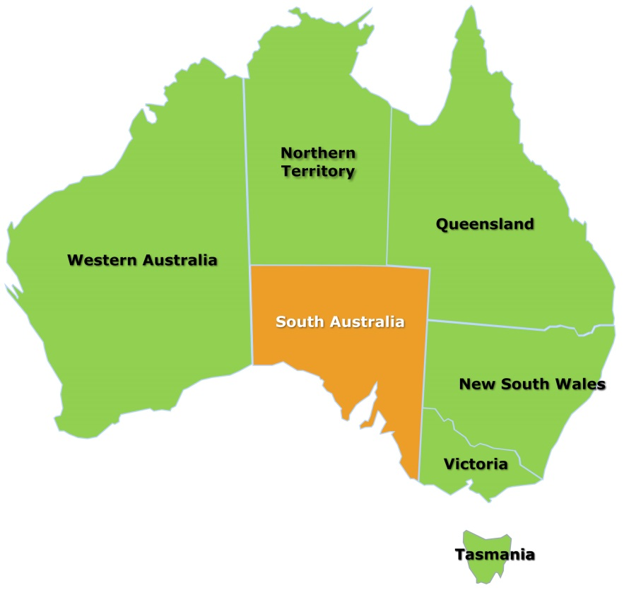
South Australia
- Has more than 56% of Australia’s vineyard area;
- produces the equivalent of 820 million bottles of wine per year;
- crushes 45% of Australia’s wine grapes;
- has predominantly red varieties at 74% of production led by Shiraz and Cabernet Sauvignon while white varieties is led by Chardonnay;
- employs 8,440 people in grape and wine occupations;
- has 3,400 independent grape growers and 700 wineries;
- has 340 cellar doors;
- exports 70% of Australia’s wine worth $1.79B, exporting wine to over 100 countries;
- has 13 of the 21 ‘exceptional’ wines in the 2014 Langton’s classification;
- has both warm and cool climate wines, providing diversity of style and character; and
- some of the oldest producing grape vines in the world.
Australia’s Wine Industry: Overview
 | World  (OIV 2016) | Aus  (VHA-WA 2017) | SA  (VHA-WA 2017)
Vineyard area  ('000 ha) | 7,511 | 135  (1.8% of global, 10th) | 75  (~56% of Aus)
Grapes crushed ('000 T) | 36,336 | 1,985  (5% of global, 6th) | 864  (~45%)
Wine produced  (ML) | 25,900 | 1,370  (5% of global, 6th) | 612  (44%, PIRSA 2017)

Direct Employment
The South Australian Wine Industry employs 8,440 people in grape-growing and winemaking

Australia: 20,922 South Australia: 8,440

South Australian Vineyards - Regions
South Australia has more than 50% of Australia’s vineyards (VHA 2017)

South Australian Vineyards: A Range of Climates
- South Australia’s climate and low rainfall means less pests and diseases in the vineyard
- South Australia produces both warm and cool climates wines providing diversity of style and character
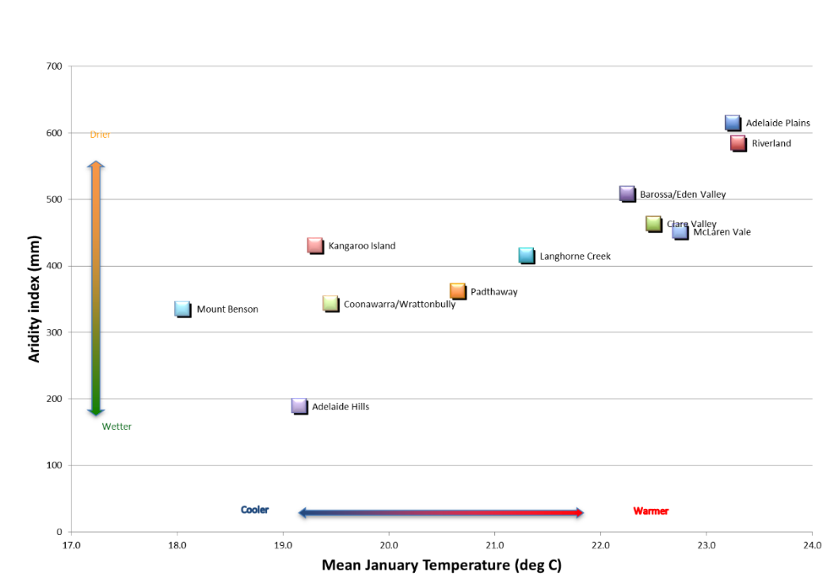
South Australia has a range of viticultural climates. Generally speaking, the regions range from cool to warm. Whilst there are quite marked differences in total annual rainfall, rainfall during the growing season (defined as October to March inclusive) is generally low, meaning lower disease pressure.

South Australian Vineyards – Growers
- There are 3,403 vineyards in South Australia registered with Vinehealth Australia
- The average vineyard size is 22.4 ha
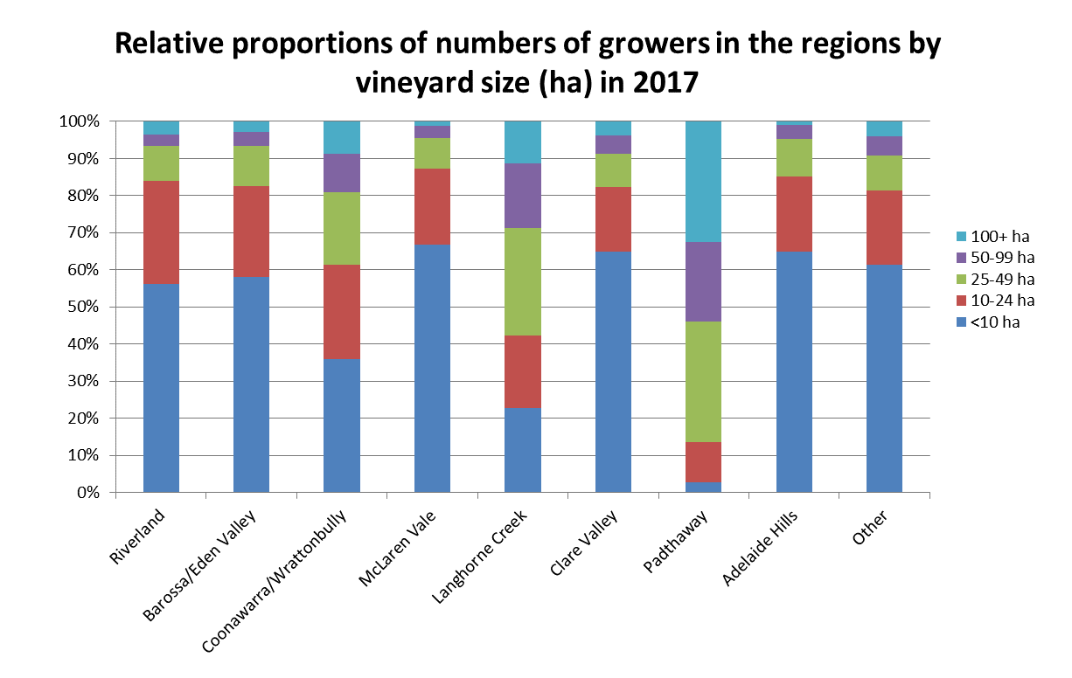
The majority of vineyards are <10 hectare except in:
- Langhorne Creek – mainly 25-50 ha
- Padthaway – mainly >50 ha

South Australian Vineyards: Varieties
- Reds account for 64% of South Australia’s crush @ 549,000 tonnes (Wine Grape Crush Survey 2017)
- Whites account for 36% @ 315,000 tonnes (Wine Grape Crush Survey 2017)
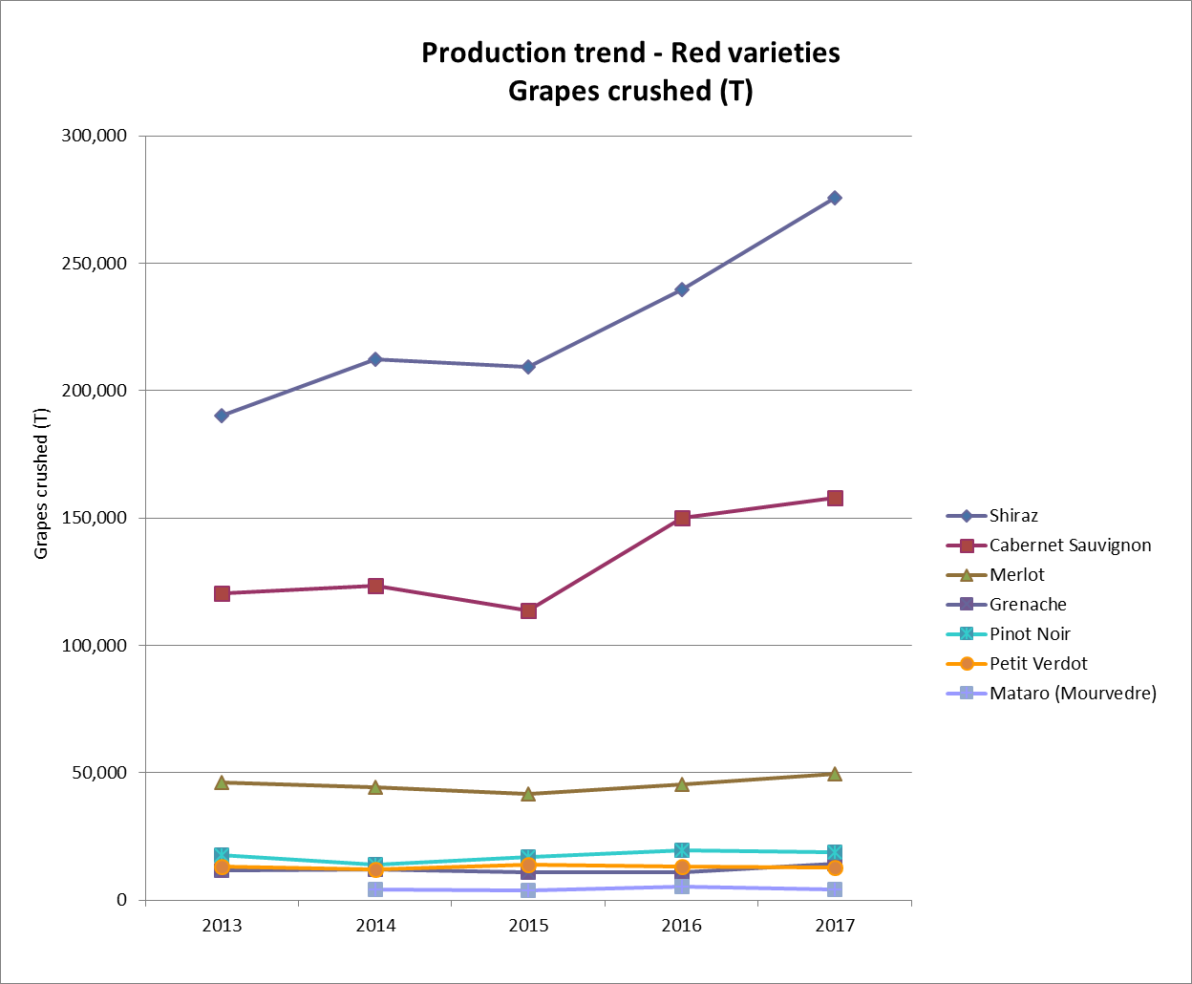
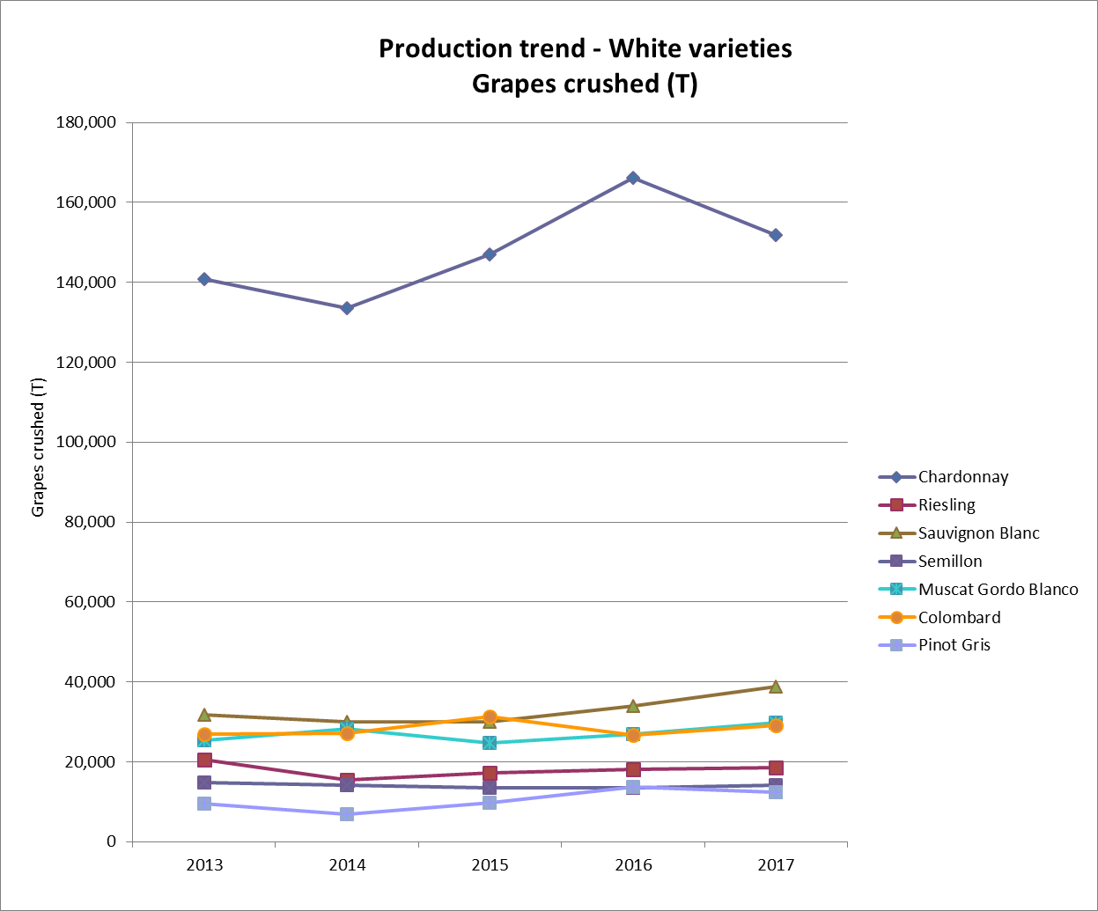

South Australia’s Top Grape Varieties
RED  Shiraz  Cabernet Sauvignon  Merlot  Grenache  Pinot Noir  In red, major varieties continue to be Shiraz, Cabernet Sauvignon, and Merlot, however less traditional varieties including Grenache, Mataro/ Mourvèdre, Malbec, Tempranillo,  Petit Verdot, Sangiovese, are increasingly diversifying production  - Shiraz is 36% of SA crush  - Cabernet 23%  - Merlot 5%  - Grenache 2%  - Pinot Noir 2% | WHITE  Chardonnay  Riesling  Sauvignon Blanc  Semillon  Pinot Gris  In white, Chardonnay, Riesling, and Sauvignon Blanc, continue to comprise the greatest plantings, however less traditional varieties including Pinot Gris, Fiano and Viognier are growing in popularity  - Chardonnay 12%  - Riesling 3%  - Sauvignon Blanc 3%  - Semillon 1%  - Pinot Gris 1%

SA Wineries: Cellar Door Visitor Centres
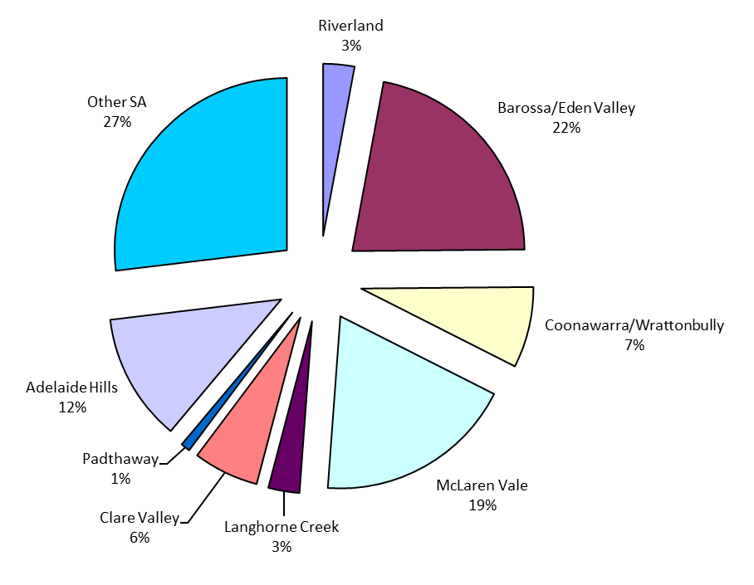
South Australia has more than 340 wineries with a cellar door for visitors to sample wines and enjoy tourism experiences

Australian Wine Exports: Overview
~70% of Australian wine exports are from South Australia

(2017 Wine Australia Export database | Australia | South  Australia
Volume (ML) | 811 | 558  (69% of Aus)
Value ($ million) | $2,562 | $1,786  (70% of Aus)

South Australia Wine Exports: Destinations
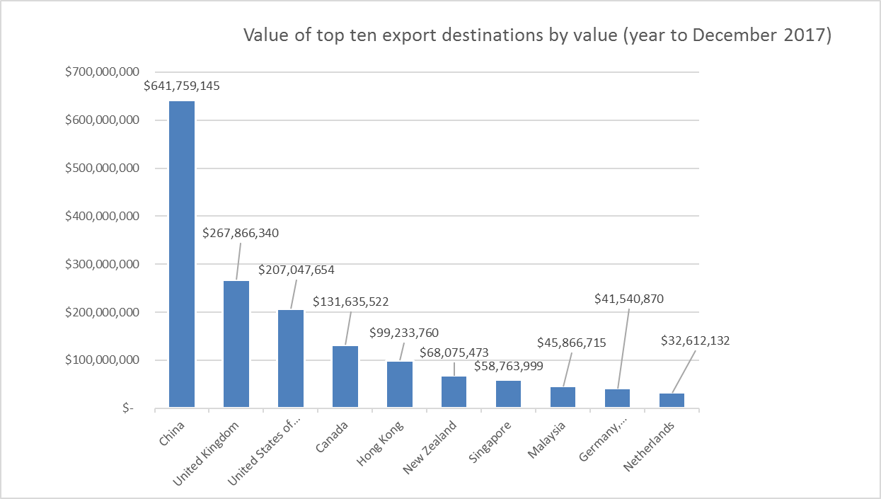

Number of businesses based in South Australia exporting to the top destinations (September 2017)
Country | Number of exporters
CHINA, PR | 420
UNITED KINGDOM | 183
CANADA | 133
UNITED STATES OF AMERICA | 132
JAPAN | 100
NEW ZEALAND | 93
DENMARK | 85
GERMANY, FEDERAL REPUBLIC | 76
NETHERLANDS | 41
FINLAND | 18

Wine Exports: South Australian Top Exporters
10 out of the top 20 wine exporters are South Australian Wineries (2017)
Accolade Wines
Treasury Wine Estates
Casella Wines
Pernod Ricard Winemakers
Australian Vintage
Andrew Peace Wines
De Bortoli Wines
Kingston Estate
The Yalumba Wine Company
McWilliam's Wines Group
Nugan Estate
Berton Vineyards
Angove Family Winemakers
Warburn Estate
The Tahbilk Group
Idyll Wine C. (Littore Family Wines)
Wingara Wine Group
Salena Estate
Qualia Wine Services
Brown Brothers
Zilzie Wines
Taylors Wines

Premium South Australian Wines
13 of the 21 “Exceptional” Wines in the Langton’s Classification 2014 were from South Australian Producers.
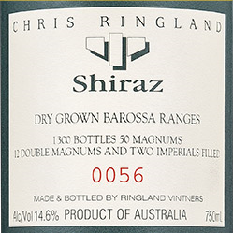
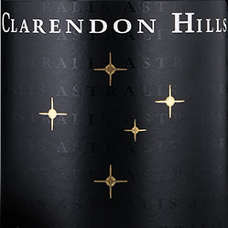
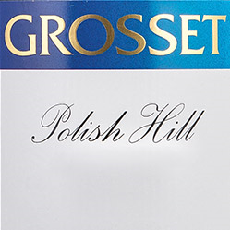
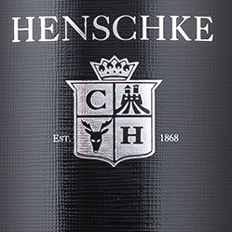
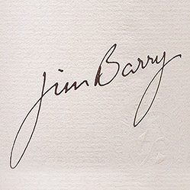
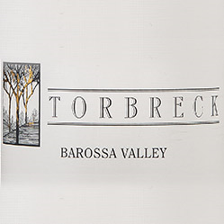
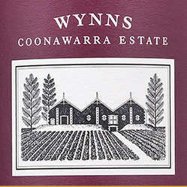
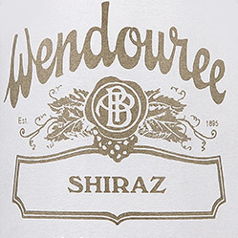
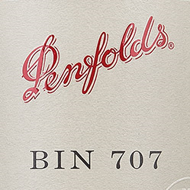
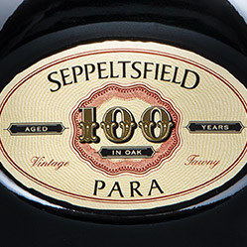
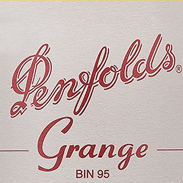

SA Wine Sector: Economic Value (2016-17)
- Gross Wine Revenue: $2.35billion
- Farm gate value: $658 million
- 2.3% of total Gross State Product (GSP)
- SA Wine Exports $1.475 billion
- Importance of Wine to South Australia
- Export earnings
- Regional development
- Tourism
- Employment
- Education & Research
- Agricultural Innovation

- South Australia - The Heart of Australian Wine
- South Australia has internationally acclaimed wines and world renowned brands including Penfolds, Grange & Henschke, and Hill of Grace.
- South Australia has both affordable and luxury wines and commercial and boutique brands.
- We have both warm and cool climates wines and, providing diversity of style and character in every category.
- South Australia has some of the oldest producing grapevines in the world.
- Many of Australia’s largest wine companies have head offices and their production bases in South Australia.
- South Australian wine regions have strong domestic and international market awareness and reputations, e.g. Barossa, McLaren Vale, Coonawarra.
- Visitors to South Australia can taste wines at 340 cellar doors across the state
- South Australia produces predominantly red wines in all regions except the Adelaide Hills where cool climate whites predominate.
- South Australian Wine Exports contributed $1.786 Billion to the state economy in 2017.
- South Australian wine is exported to over 100 countries, with the major markets being China, UK, USA, and Canada .
- 8,440 South Australians are directly employed in grape-growing and winemaking.
- The South Australian wine industry is Phylloxera free - one of the few places in the world free of the vine destroying pest.
- South Australia produces a higher proportion of flagship and premium wine than the other Australian states.
- South Australia produces (45%) of the national grape and wine production.
- South Australian wine constitutes nearly 70% of Australian wine exports (2017)
- The national wine industry organisations, including marketing, education and research & development institutions have their headquarters in South Australia, providing collaboration, leadership, innovation and expertise in winemaking and viticulture.

I’ve included both as WGCSA doesn’t have winery vineyards as members – one to discuss!
An area where we could examine cost sharing

